HCI101 PROJECT DEVELOPMENT

INTERACTION DESIGN IN JAVASCRIPT WITH LOCAL STORAGE

**By: Team 4**

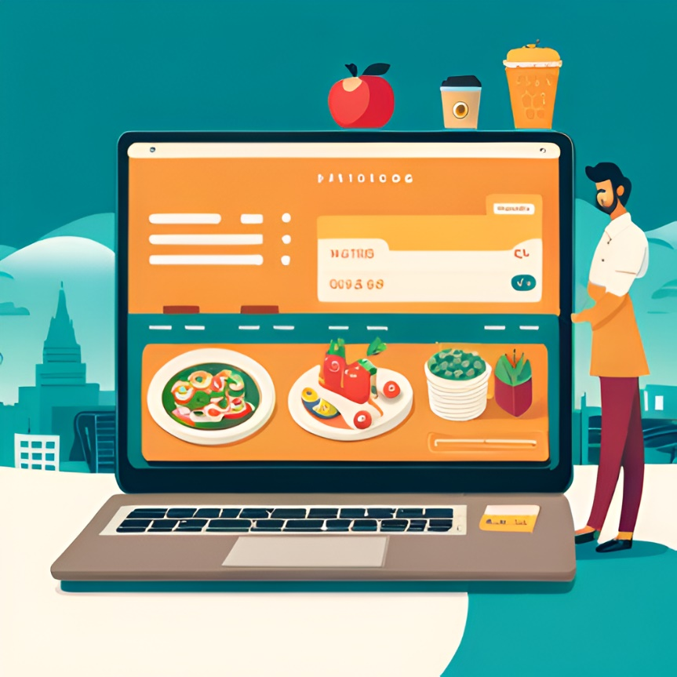**Navigating the Flavors of Menulog: A User Flow**

**Introduction to Menulog**

Menulog is an online food delivery platform that connects customers with their favorite local restaurants. The platform offers a wide range of cuisines, from Indian to Italian, and allows users to easily order their favorite dishes with just a few clicks.

One of the key features of Menulog is its user-friendly interface. The platform is easy to navigate, with clear menus and intuitive search functions that make it simple for users to find what they are looking for.

**Creating an Account on Menulog**

To use Menulog, users must first create an account. This process is quick and straightforward, requiring only basic information such as name, email address, and password.

Once an account has been created, users can save their favorite restaurants and dishes, making it even easier to order food in the future.

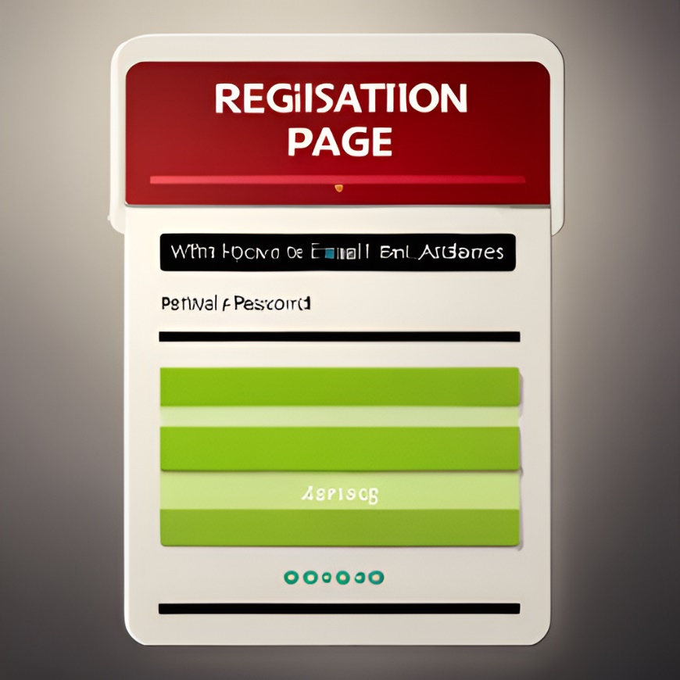

**Browsing Restaurants and Menus on Menulog**

Menulog offers a wide selection of restaurants and cuisines, making it easy for users to find something that suits their tastes. Users can browse by cuisine type, location, or restaurant name, and can filter results by price, rating, and other factors.

Each restaurant on Menulog has its own menu, which users can browse and add items to their cart. Menulog also offers detailed information about each dish, including ingredients and allergen information, to help users make informed choices

**Placing an Order on Menulog**

Once users have selected their desired items from a restaurant's menu, they can proceed to checkout. Menulog offers multiple payment options, including credit card and PayPal, making it easy for users to pay for their order.

After an order has been placed, users can track its progress in real time, with updates on when the food is being prepared, when it is out for delivery, and when it has been delivered.

**Conclusion**

Overall, Menulog is a convenient and user-friendly platform that makes it easy for customers to order food from their favorite local restaurants. With a wide selection of cuisines, detailed menus, and multiple payment options, Menulog is a great choice for anyone looking for a hassle-free food delivery experience.

Whether you're ordering in for a night at home or need to feed a group of hungry friends, Menulog has you covered.

**User Flows**